# Big Mountain Resort Guided Capstone Project Summary

Big Mountain Resort, a ski resort located in Montana, serves about 350,000 people each year for skiing or snowboarding activities. With a rich set of facilities and terrain the resort can accommodate skiers and riders of all levels and abilities. With an investment of $1.54 million for this season for an additional chairlift, the company wants to develop a business strategy to maximize its revenue potential by providing the best value to their customers based on their level of facilities compared to other resorts in their market.

## Problem Statement

What opportunities exist for Big Mountain Resort to maximize revenue by optimizing ticket prices based on the thesis of ‘best value to their customers’ by comparing their facilities with other resorts in their market segment using data-driven strategies?

## Solution Methodology

The Data Science Method (DSM) steps as shown below were adopted to develop and analyze the ticket pricing model for the Big Mountain resort compared to other resorts in their market segment:

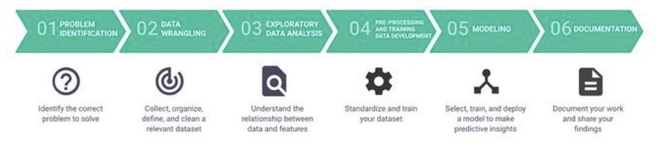

## Recommendations

During the course of the modeling, management team shared 4 different scenario and those scenarios are listed below along with the recommendations:

**Scenario 1**: Permanently close down up to 10 of the least used runs in order to reduce the operating cost of the company.

Based on the model, the team should consider closing a minimum of one run and ideally 6-10 of the least used runs. The model suggests that closing one run would result in no difference in revenue. Closing two runs reduced revenue, and closing three runs reduces revenue further. There is no further change in revenue when closing four or five runs. After 6 runs are closed there isn’t as large a reduction in revenue so it may be more profitable to keep 6-10 of the least used runs closed unless they are at max capacity.

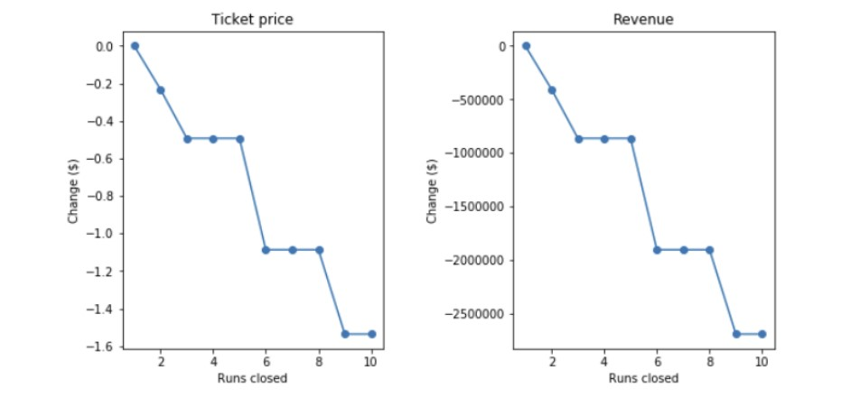

**Scenario 2**: Increase the vertical drop by adding a run to a point 150 feet lower down but requiring the installation of an additional chair lift to bring skiers back up, without additional snow making coverage.

Based on the model, in this scenario Big Mountain can increase the ticket prices by $1.99 which will amount to increase in revenue by $3,474,638 over the season.

**Scenario 3**: Same as Scenario 2 with additional snow making coverage of 2 acres.

No increase in the revenue and the capital cost as well as the operating cost will go up due to additional snow coverage, hence this is not recommended.

**Scenario 4**: Increase the longest run by 0.2 miles and guaranteeing its snow coverage by adding 4 acres of snow making capability.

No increase in the revenue and the capital cost as well as the operating cost will go up due to additional snow coverage, hence this is not recommended.

## Recommended Next Steps

1. While a data-driven strategy for the ticket pricing has been developed, it is recommended that the marketing team analyze the relationships between ticket pricing and resort facilities based on their experience and if required by engaging a resort pricing consultant. This will increase the confidence in the model to keep increasing the model maturity.

2. Build a production ticket pricing model to empower the marketing team to continue to explore potential opportunities to reduce costs and increase revenues.

## References

Problem Statement Hypothesis  
<https://github.com/dancing-badger/DataScienceGuidedCapstone/blob/master/Notebooks/Big_Mountain_Resort_Problem_Statement.pptx>

Data Wrangling  
<https://github.com/dancing-badger/DataScienceGuidedCapstone/blob/master/Notebooks/02_data_wrangling.ipynb>

Exploratory Data Analysis  
<https://github.com/dancing-badger/DataScienceGuidedCapstone/blob/master/Notebooks/03_exploratory_data_analysis.ipynb>

Preprocessing & Training Data  
<https://github.com/dancing-badger/DataScienceGuidedCapstone/blob/master/Notebooks/04_preprocessing_and_training.ipynb>

Final Modeling  
<https://github.com/dancing-badger/DataScienceGuidedCapstone/blob/master/Notebooks/05_modeling.ipynb>